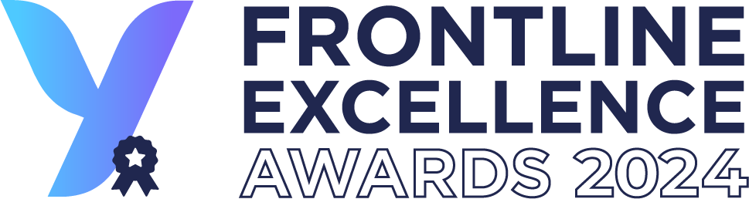

Nomination Form

Questions & Guidance

This document is for guidance only. To make a nomination, please submit an official nomination form.

Introduction
YOOBIC’s Frontline Excellence Awards is the annual recognition and celebration of the pioneering individuals and teams within our customer community, who are improving their frontline experience through exceptional strategy, teamwork, and dedication.
Do you know a remarkable frontline leader or team that fits the bill? Is it you or your team?
Nominations are now OPEN!
Learn more about the program, award categories, and FAQ here.
The deadline to nominate is Thursday, May 2, 2024.
It’s 100% free to nominate and win. You may submit nominations for as many award categories as you like — but you must fill out a new form for each nomination.
What makes a great nomination?
The nomination form comprises 15 questions to help our jury evaluate nominees. We’ll ask you to share the opportunities or challenges the nominee faced, how they strategically navigated them, and the exciting outcomes.
Many of the questions are open-ended to encourage your candor, introspection, and insight. Please be thorough with your responses and provide success metrics where you can.
At the end of the form, you’ll have the option to upload supporting files, such as video, graphics, PowerPoint presentation, or other documents that showcase how your nominee(s) meet(s) the Award criteria. Don’t skip this step! Most of last year’s winning nominations included supporting documents. It’s worth it.

2. Nomination Form
Below are the questions you’ll be asked to answer in the nomination form. Use this document to review and answer the questions before submitting an official nomination here.

Information about your company:

What is the name of your company?*

Where is your company HQ located?*

What year did your company start using YOOBIC? (optional)

Tell us the number of locations using YOOBIC (optional, if relevant)

# of stores, sites, restaurants

How many YOOBIC users are there in your company?*
Tell us the total number of people using YOOBIC in your company. You don’t have to give details per role.

Information about the person submitting the nomination:
(So we can contact you about your nomination and the Awards results.)

What's your full name?*

What is your job title?*

What’s your email address?*

Award categories:

Which category are you nominating for?
Select only one option in the list. (You can apply for multiple awards but you need to submit a new nomination form for each award category. See award categories descriptions here.)
- Individual - Transformation Leader of the Year
- Individual - YOOBIC Administrator of the Year
- Individual - Frontline Excellence Advocate of the Year
- Individual - District Leader of the Year
- Individual - Frontline Hero of the Year
- Team - Employee Experience Program of The Year
- Team - Customer Experience Program of The Year
- Team - Learning Program of The Year
- Team - Operational Excellence Program of The Year
- Team - Project Launch of the Year

Information about your nominee (for individual awards only)

What's the full name of your nominee?*

What's the job title of your nominee?*

Information about your nomination
In this section, we are asking you for more information about why you think your nominee should win the award; what challenges your company/your nominee(s) faced and solved with YOOBIC; and the primary outcomes. These are the most important questions of the nomination form and the jury will look closely at your answers to compare nominees.

What makes your nominee (individual or team) the perfect choice for the award you selected?
Tell us about the specific qualities, achievements, values, and attitudes that make them the obvious choice.

Tell us more about the business challenges that your nominee solved with YOOBIC.
Please provide a description of the business challenges faced and the specific strategies employed to address them with YOOBIC. Please be as detailed as possible in your explanation. Call out any specific YOOBIC features if applicable.
Here are some of the key ways YOOBIC contributes to frontline excellence:
  - Unified Communication
  - Team Community Development
  - Perfect Task Execution
  - Operational Execution
  - Unified Health & Safety Procedures
  - Centralized Knowledge Library
  - Site Visits & Audits
  - Visual Merchandising
  - In-Store Promotions
  - Quality Inspections
  - Mobile Learning
  - Microlearning
  - Gamification & Social Learning
  - Performance Incentives
  - Product Visibility & Image Recognition
  - Engagement Analysis
  - Fast Request Resolution

How is YOOBIC creating value at your company? Please select 1 or 2 answers.
  - Drive operational excellence & efficiency
  - Increase sales
  - Improve employee experience
  - Improve customer experience
  - Manage reputational & regulatory risks

What were the outcomes?
Try to include any metrics and relevant KPIs to help communicate success. Metrics can be given in actual value or as a % increase or decrease over a period of time.

Here are examples of KPIs shared by previous award winners:
Platform Metrics Examples
- YOOBIC adoption rates, active users
- User engagement (number of likes, comments, shares)
- Digitization of tasks (# or %)
- Time to execute tasks & time-savings (on store visits, on task completion in-store, etc.)
- Compliance rates ( SOPs, visual merchandising…)
- Learning KPIs (# of learners engaged, # of courses completed, course completion rates, compare before and after YOOBIC)
- Decrease (or complete stop) in number of emails
- Decrease in number of tools/apps used
Business Metrics Examples
- Increase in Employer Net Promoter Score (eNPS) and employee retention
- Increase in in-store conversion rates (e.g. sales per sqm / per associate)
- Increase in basket size or units per transaction (UPT)
- Increase in customer service satisfaction / ratings
- Cost savings ( e.g. work hours, travel & expenses, print costs, etc.)

Upload your supporting documents (up to 3)
This is optional but HIGHLY recommended! Add any supporting documents to help tell the story of your nomination(s). Past winners have provided presentations, videos, photos, etc.) Note: Any document you provide will remain confidential. It will only be visible to jury members.
Many of last year’s winners attached a short PowerPoint presentation detailing their achievements. Here is an example:
- Part 1: Presentation of individual or team nominee
- Part 2: Three to five reasons why the nominee should win the award
- Part 3: Challenges the nominee faced and how they solved them using YOOBIC
- Part 4: Outcome of the project with clear KPIs
Don’t hesitate to include images and screenshots of the content you created in the YOOBIC app!

Don’t forget: The submission deadline is May 2, 2024.
We look forward to receiving your nominations. If you have any additional questions or need assistance, reach out to your YOOBIC CS team.
Good luck and have fun!
— The YOOBIC team

